***AEC* *LAB REPORT – 4***

***BJT Characterization***

***NAME:*** *Khyathi Sri Basireddy*

***ROLL NO****: 2023102065*

***TABLE NO: 9***

***1.BJT Characterization***

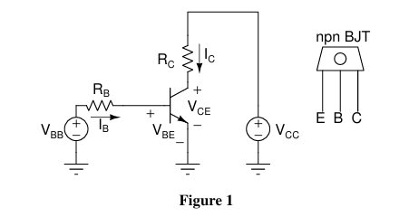E – Emitter B – Base C – Collector

*Given above is the common emitter configuration.*

*RB = 10k ohm*

*RC = 1k ohm*

*VCC = 12 V*

*Input – Sine Wave*

*Vpp = 4V*

*Offset = 2V*

*Channel – 1 🡪 VBB*

*Channel – 2 🡪 VBE*

* Connect the circuit as shown in Fig and by using xy-mode in Acquire of the oscilloscope plot VBE (CH2) (Y-axis) vs VBB (CH1) (X-ais) for VBB = 0 V to VBB = 4 V.
* In this way we can the plot voltage quantities.
* However, you can find the value of current by KVL and ohm’s law. For example, in Fig. base and collector currents (IB & IC) can be calculated as follows:

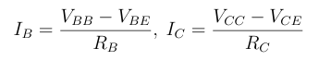

* Now for the same experimental setup, plot VCE (CH-2) with respect to VBB (CH1). Tabulate and calculate VCE and IC for same set of VBB used in the previous part.
* Calculate common emitter current gain β = IC/IB.
* Also report the mode of operation of BJT.

***(a) VBE vs VBB plots***

Observe the values of VBB and VBE at the bottom of each photo obtained using the cursor.

VBB = 0.2V

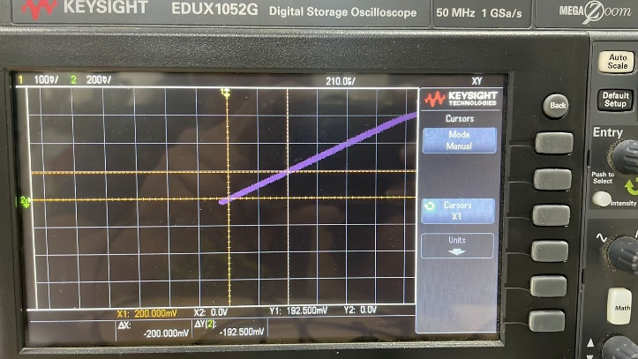

VBB = 0.3V

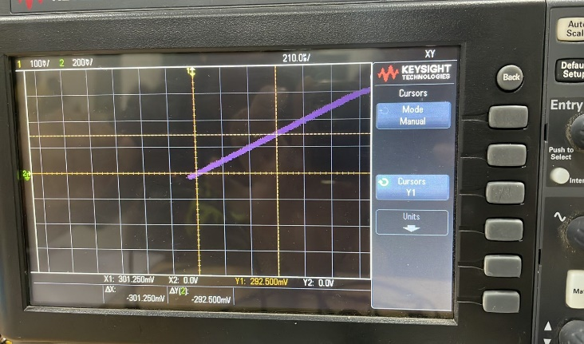

VBB = 0.4V

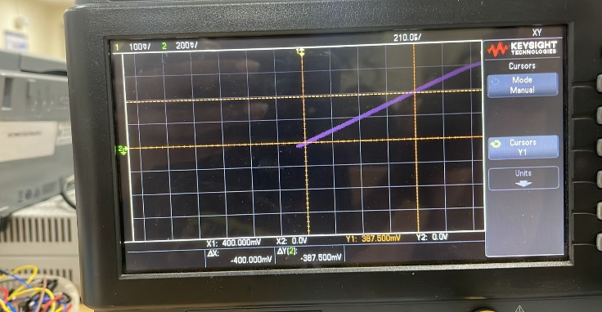

VBB = 0.5V

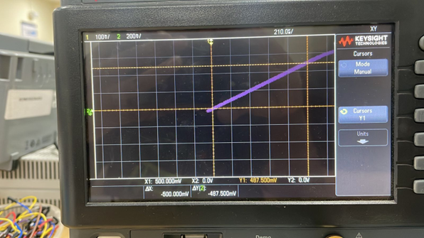

VBB = 0.6V

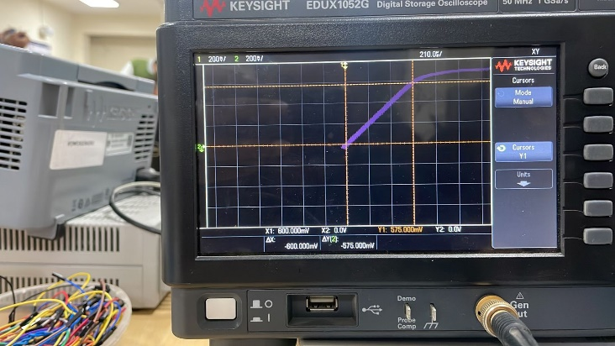

VBB = 0.7V

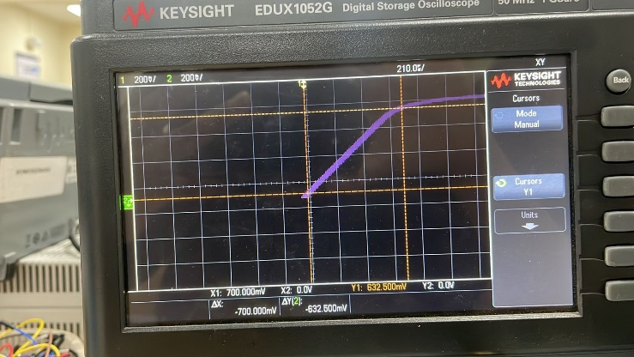

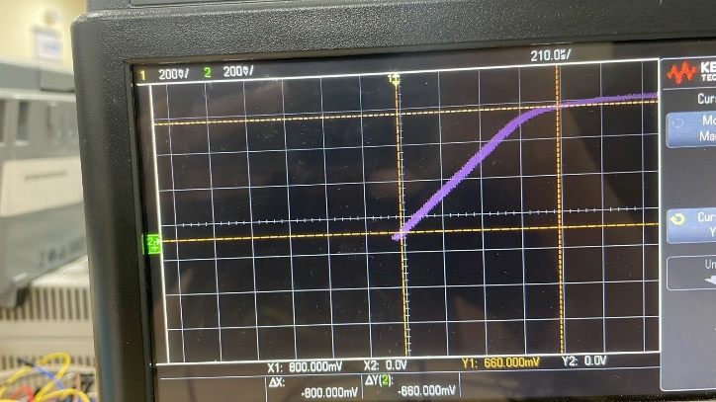VBB = 0.8V

VBB = 0.9V

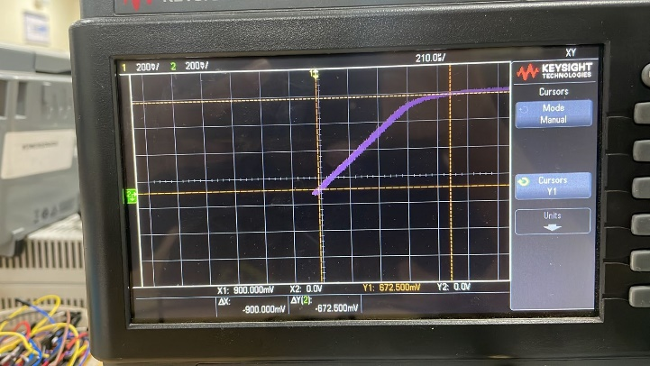

VBB = 1V 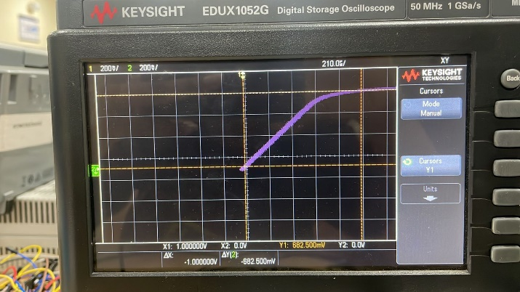

VBB = 1.2V

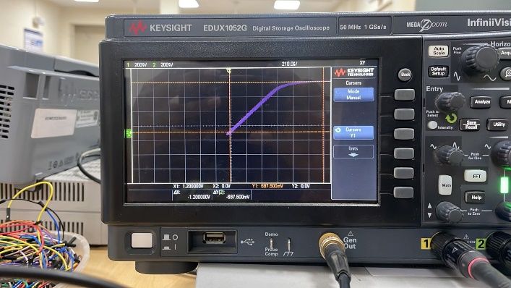

VBB = 1.4V

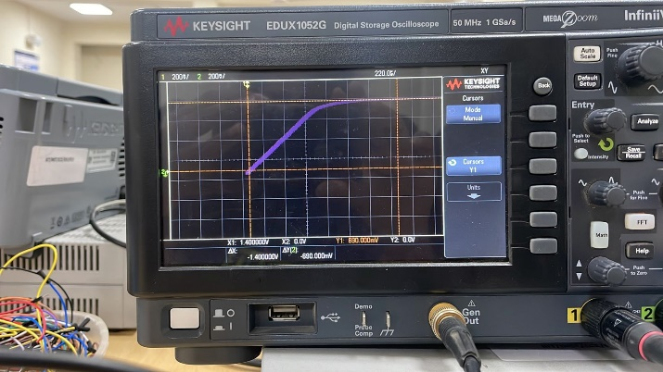

VBB = 1.6V

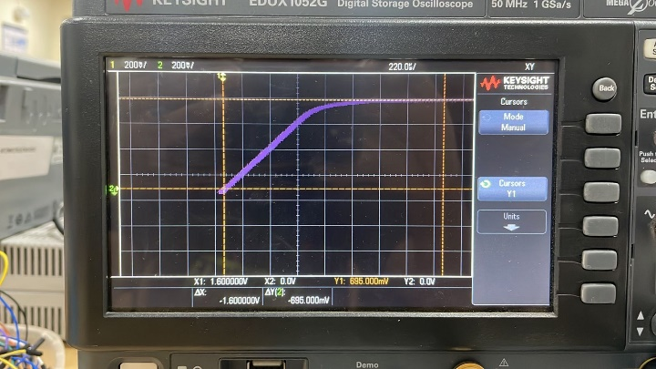

VBB = 1.8V

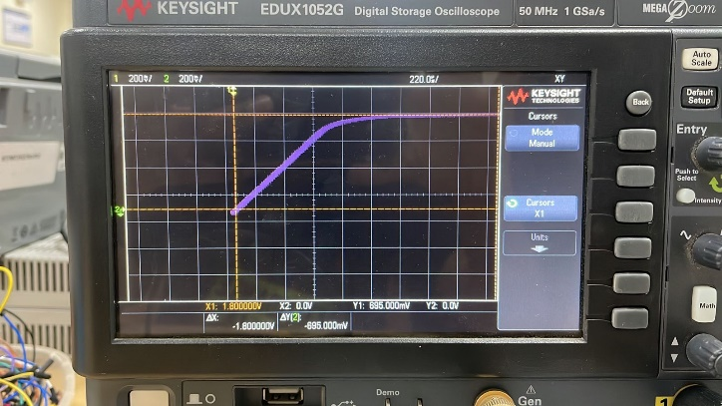

VBB = 2V

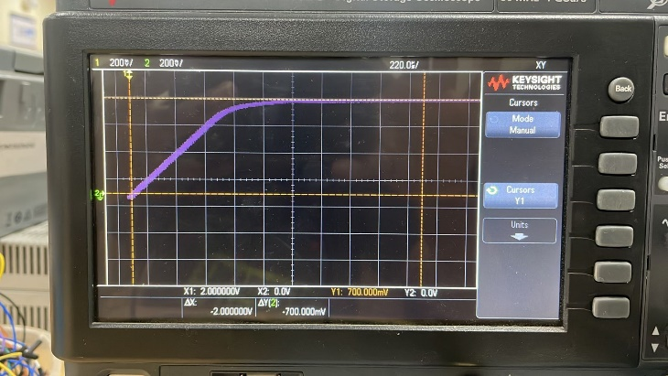

VBB = 3V

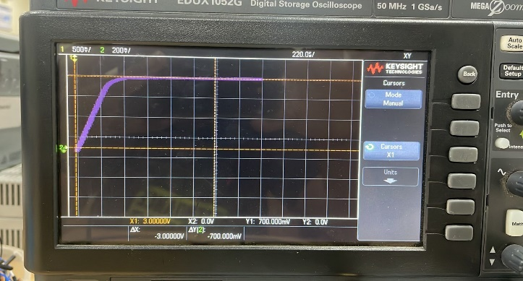

VBB = 4V

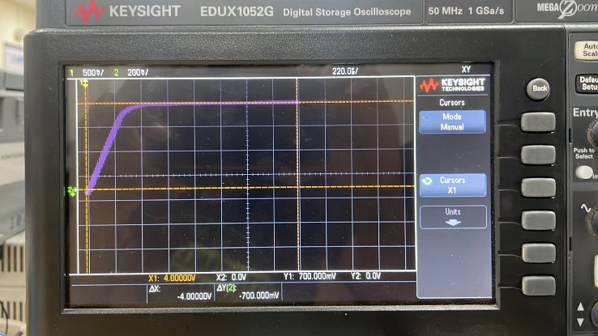

***(b) VCE vs VBB plots***

Observe the values of VBB and VCE at the bottom of each photo obtained using the cursor.

VBB = 0.2V

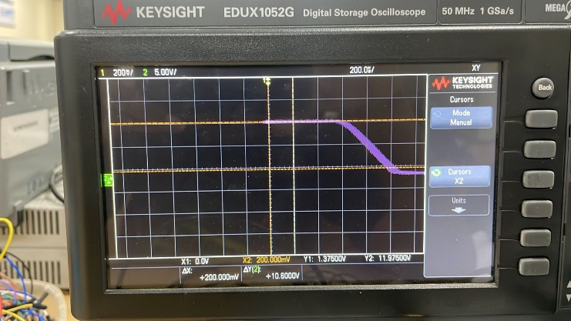

VBB = 0.3V

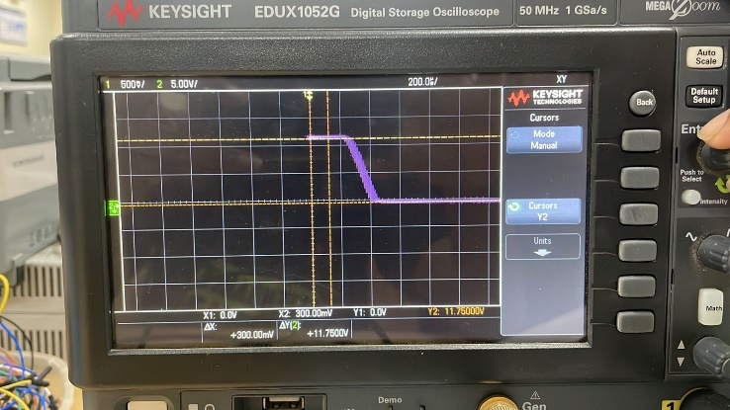

VBB = 0.4V

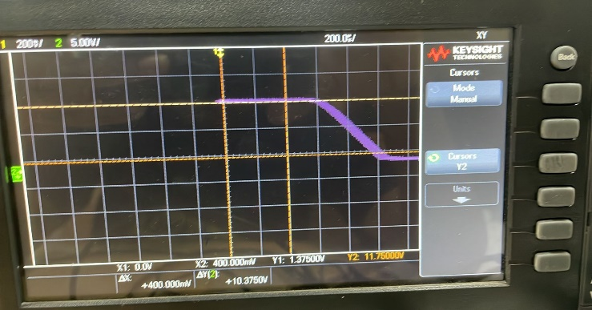

VBB = 0.5V

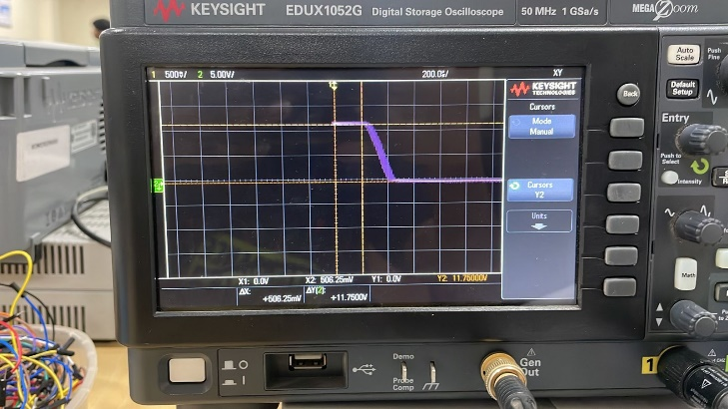

VBB = 0.6V

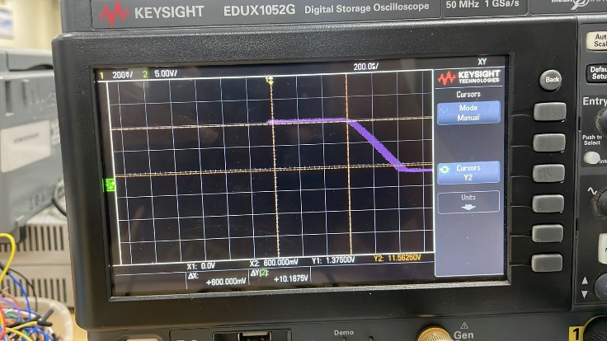

VBB = 0.7V

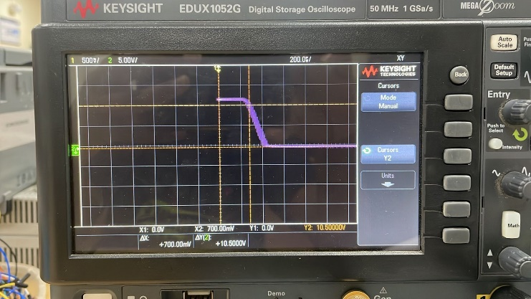

VBB = 0.8V

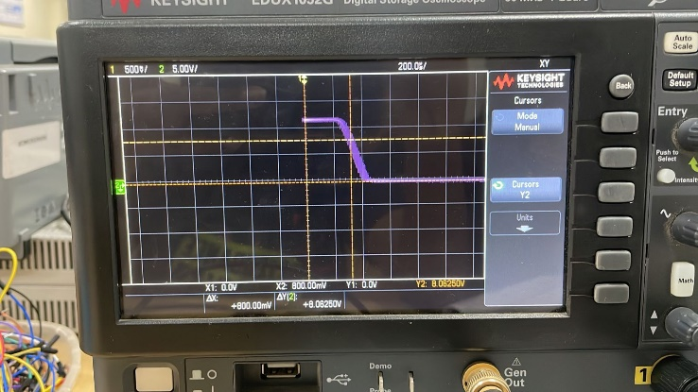

VBB = 0.9V

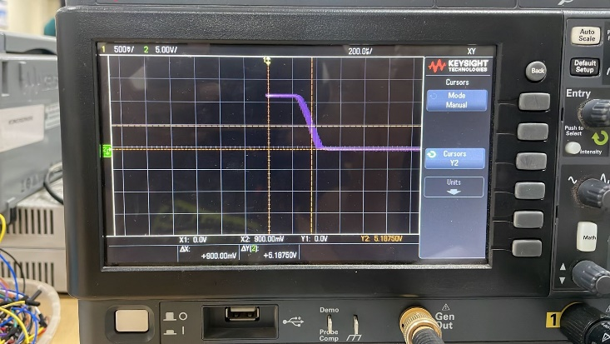

VBB = 1V

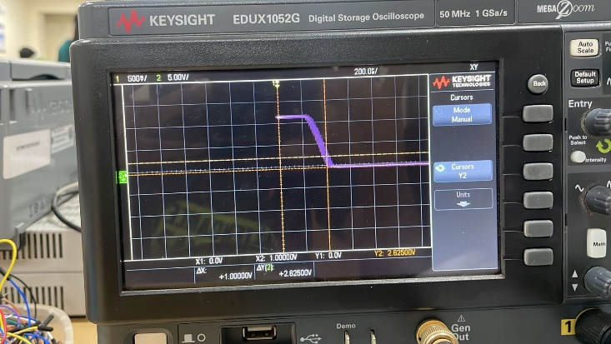

VBB = 1.2V

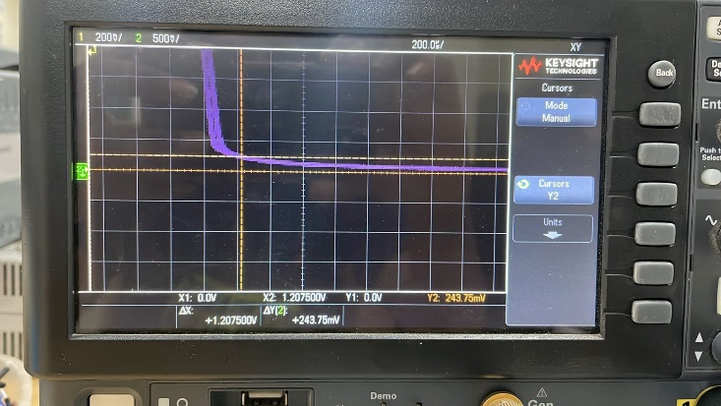

VBB = 1.4V

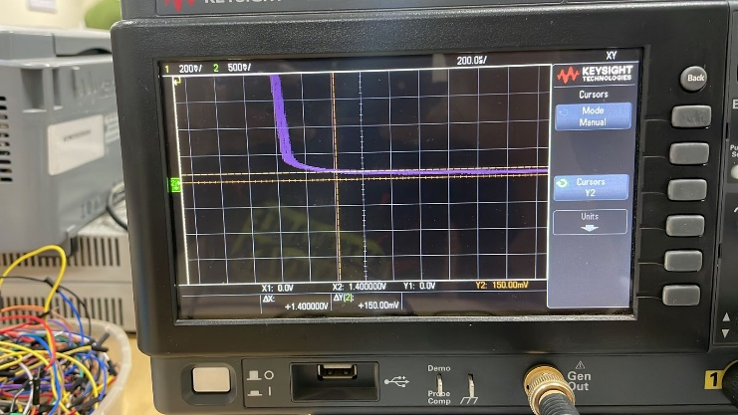

VBB = 1.6V

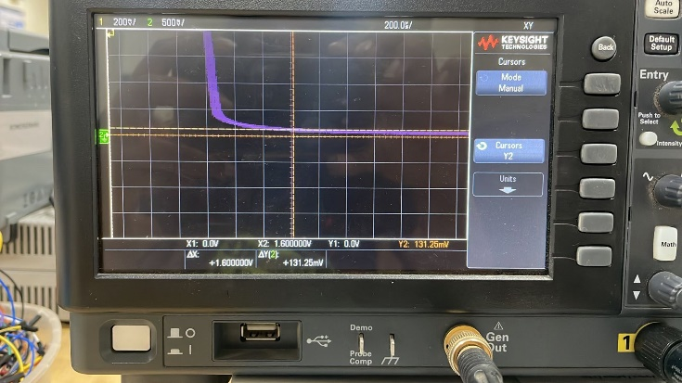

VBB = 1.8V

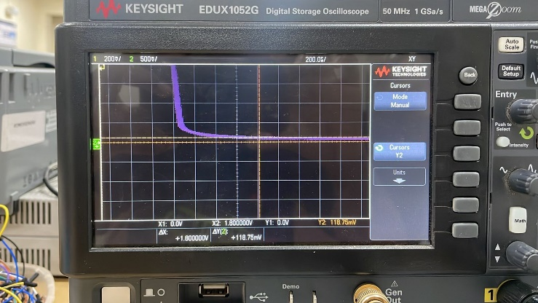

VBB = 2V

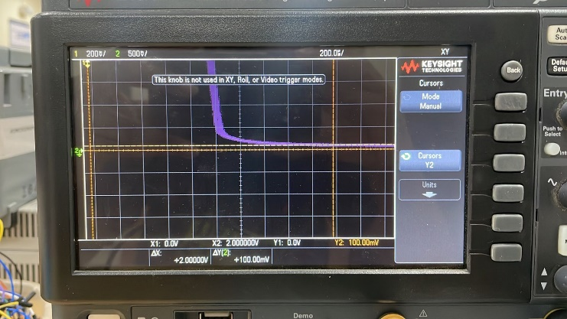

VBB = 3V

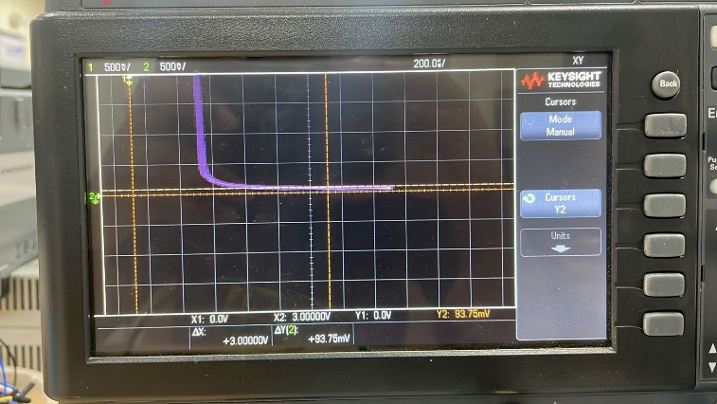

VBB = 4V

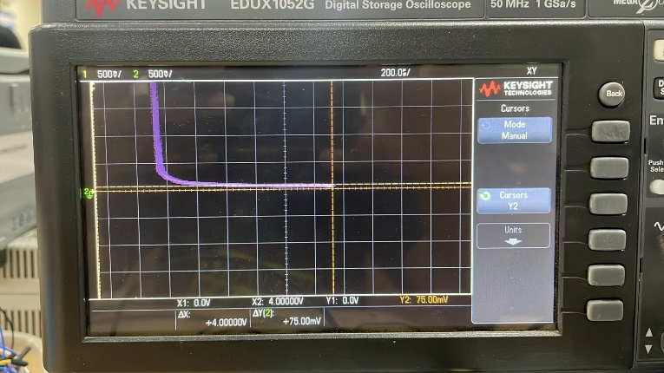

***The Output Table:***

|  |  |  |  |  |  |  |
| --- | --- | --- | --- | --- | --- | --- |
| ***VBB(V)*** | ***VBE(mV)*** | ***IB(uA)*** | ***VCE(V)*** | ***IC(mA)*** | ***B = IC/IB*** | ***Mode*** |
| 0.2 | 192.5 | 0.75 | 11.975 | 0.025 | 333 | CutOff |
| 0.3 | 292.5 | 0.75 | 11.75 | 0.25 | 333 | CutOff |
| 0.4 | 387.5 | 1.25 | 11.75 | 0.25 | 200 | CutOff |
| 0.5 | 48.5 | 1.25 | 11.75 | 0.25 | 200 | CutOff |
| 0.6 | 575 | 2.5 | 11.56 | 0.44 | 176 | CutOff |
| 0.7 | 632.5 | 6.8 | 10.5 | 1.5 | 220 | Active |
| 0.8 | 660 | 14 | 8.0625 | 3.93 | 280 | Active |
| 0.9 | 672.5 | 22.8 | 5.187 | 6.813 | 298.8 | Active |
| 1 | 682.5 | 31.75 | 2.625 | 9.375 | 295.2 | Active |
| 1.2 | 687.5 | 51.25 | 243.75 m | 11.757 | 229.4 | Active |
| 1.4 | 690.0 | 71.0 | 150 m | 11.85 | 166.9 | Saturation |
| 1.6 | 695 | 90.5 | 131.25 m | 11.868 | 131.1 | Saturation |
| 1.8 | 695.0 | 110.5 | 118.75 m | 11.881 | 107.52 | Saturation |
| 2 | 700.0 | 130 | 100 m | 11.9 | 92.23 | Saturation |
| 3 | 700.0 | 230 | 93.75 m | 11.90 | 51.76 | Saturation |
| 4 | 700.0 | 330 | 75 m | 11.925 | 36.13 | Saturation |

***Case – 1:***

* For 0.2v<VBB<0.6V -------> CutOff Mode
* VBB< VCE
* Both Base-Emitter junction and Collector Base junction are in Reverse Bias

***Case – 2:***

* For VBB>1.4 --------> Saturation Mode
* VBE>VD(cut-in voltage(0.7))
* VBE > 0 and VBE > VCE
* Both Base-Emitter junction and Collector Base junction are in Forward bias.

***Case – 3:***

* For 0.7 <= VBB<1.4 -------> Active Mode
* VBE < VD(cut-in voltage(0.7))
* VBE > 0 and VBE < VCE
* Base-Emitter junction is in Forward bias and Collector Base junction is in reverse bias.

***2.BJT Output Characterization (IC vs VCE)***

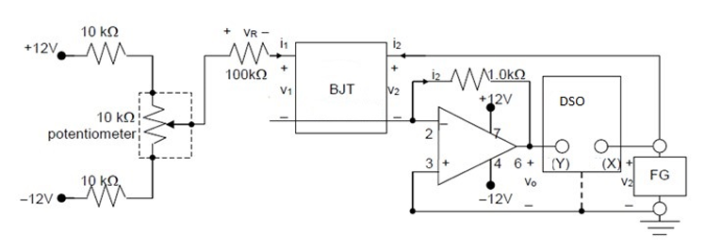

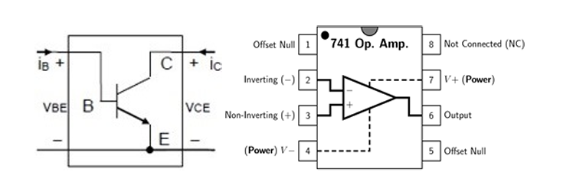

As shown in Fig. at the top, in this experiment we will use operational amplifier to plot the required BJT characteristics. It is known that V2 = VCE and V0 = −I2 ×R0 = −IE ×R0 ≈ −IC ×R0, where R0 = 1 kΩ(between node 2 and 6). Therefore, plot of IC will be proportional to V0. We will sweep V2 = VCE using the function generator and plot V0 (∝ −IC).

***Input:***

Channel 1 – VCE

Channel 2 – Output of OpAmp(Vo)

Function Generator:

Sine Wave

Frequency = 100Hz

Vpp = 8V

Offset = 4V

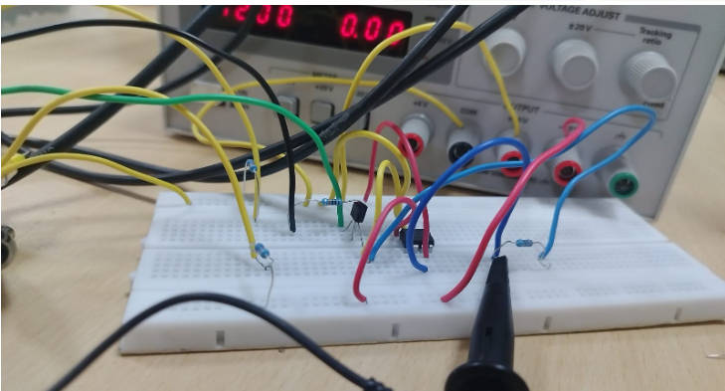

Note down these values in a table and calculate the value of IC (collector current) and IB (base current) using the below formula for each value of VBB taken in the range of 0 to 4 Volt.

IB = (VBB – VBE) / RB

IC = (VCC – VCE) / RC

Now calculate β (common emitter current gain) by using the formula

β = IC / IB

The observations are written in below table:

|  |  |  |  |  |  |  |
| --- | --- | --- | --- | --- | --- | --- |
| ***VBB*** | ***VBE*** | ***IB*** | ***VCE*** | ***Vo*** | ***IC*** | ***β = IC/IB*** |
| 0.2 | 0.19 | 0.1 | 3.96 | 0 | 0 | 0 |
| 0.3 | 0.29 | 0.1 | 4.07 | 0 | 0 | 0 |
| 0.4 | 0.37 | 0.3 | 4.14 | 0 | 0 | 0 |
| 0.5 | 0.43 | 0.7 | 3.97 | -75m | 75m | 107.1 |
| 0.6 | 0.51 | 0.9 | 3.95 | -162m | 162m | 180 |
| 0.7 | 0.52 | 1.8 | 4.39 | -355m | 355m | 197 |
| 0.8 | 0.57 | 2.3 | 4.01 | -456m | 456m | 198.26 |
| 0.9 | 0.59 | 3.1 | 4.04 | -630m | 630m | 203.22 |
| 1 | 0.6 | 4 | 4.02 | -917m | 1.02 | 255 |
| 1.2 | 0.61 | 5.9 | 4.01 | -1.02 | 1.75 | 246.61 |
| 1.4 | 0.63 | 7.7 | 4.00 | -1.75 | 2.27 | 264.80 |
| 1.6 | 0.63 | 9.7 | 3.98 | -2.35 | 2.35 | 282.5 |
| 1.8 | 0.64 | 11.6 | 4.03 | -3.87 | 3.87 | 292.64 |
| 2 | 0.64 | 13.6 | 3.98 | -3.98 | 3.98 | 333.6 |
| 3 | 0.64 | 23.6 | 4.0 | -6.5 | 6.5 | 275.4 |
| 4 | 0.65 | 33.5 | 3.97 | -7.98 | 7.98 | 287.25 |

***Case – 1:***

* For 0.2v<VBB<0.4V -------> CutOff Mode
* VBB< VCE
* Both Base-Emitter junction and Collector Base junction are in Reverse Bias

***Case – 2:***

* Saturation Mode
* VBE>VD(cut-in voltage(0.7))
* VBE > 0 and VBE > VCE
* Both Base-Emitter junction and Collector Base junction are in Forward bias.

***Case – 3:***

* For 0.4 <= VBB< 4 -------> Active Mode
* VBE < VD(cut-in voltage(0.7))
* VBE > 0 and VBE < VCE
* Base-Emitter junction is in Forward bias and Collector Base junction is in reverse bias.

